**Migrations Great Barrier Reef Guide**

**Green Turtles**

The turtles come from all over. They mostly migrate down/up towards Raine island at the top of the reef.

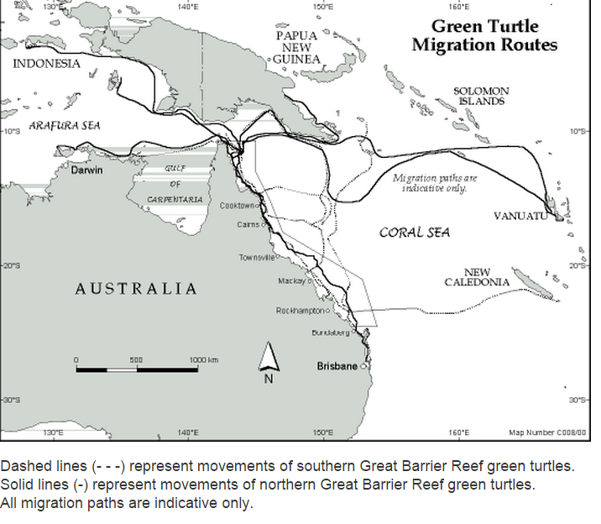

**Shearwater – Heron Island to Guam**

The shearwaters migrate from Heron Island to their winter grounds around Guam and Micronesia and vice versa.

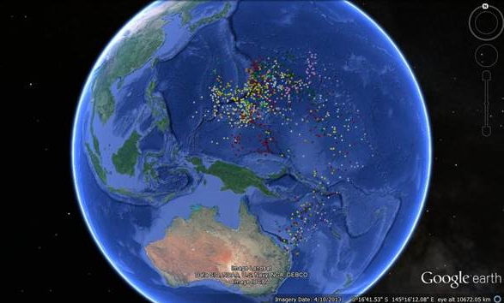

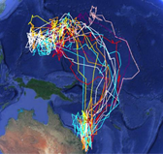

**Dwarfe Minke Whales**

The following grab is of Minke Whales. They come from the Antarctic waters and then hug the way up along the Eastern Coast of Australia all the way to the reef.

